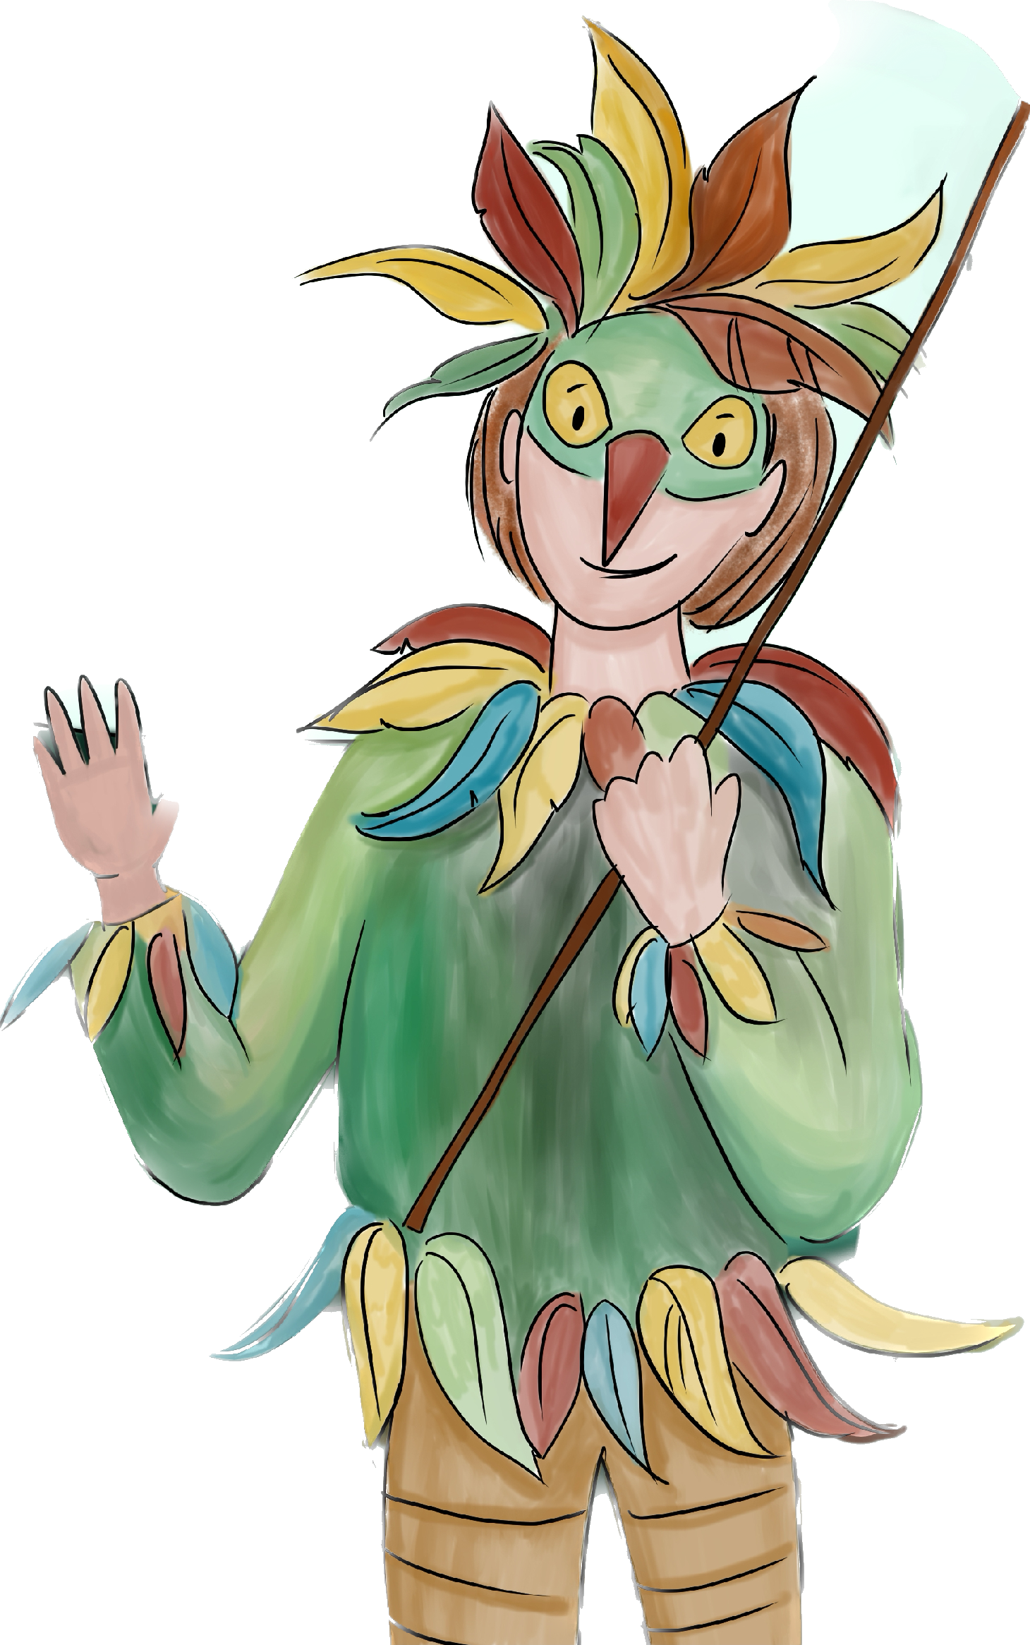
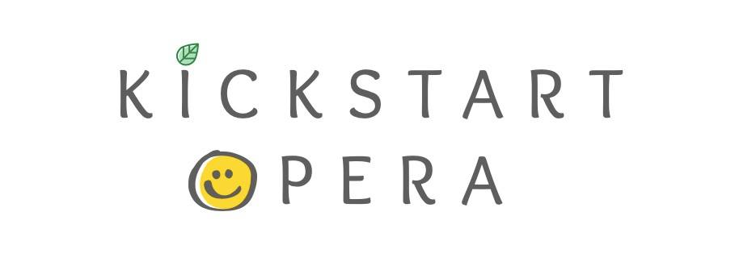

KICKSTART OPERA:
PAPAGENO’S ADVENTURE
BOOKING FORM

Before completing the booking form, please check that you are available for the course dates detailed below. If there are any dates the participant cannot attend, please make us aware of this when you submit your application.

Please ensure that you clearly state your telephone number and email address, as we will use this information to contact you further about the Papageno’s Adventure project.

Dates: 03/04/23-07/04/23
Fee: £85.00
Deposit: £25.00

(Please note that Kickstart Opera is not able to secure a place for the participant without a deposit payment).

Participant Information
Full Name: | Date of birth:
Parent/Guardian Information
Full Name:

Home address:

Mobile Number: | Email address:
Can we use the details above as an emergency contact? Yes/No
If not please give details below.

Name of contact:

Mobile number:

Email address:

Participant Medical Information
Does the participant have any allergies or medical conditions we should be aware of? Yes/No  If yes, please give details: | Does the participant have any Additional Support Needs? Yes/No  If yes, please give details:

Deposit Details
Kickstart Opera  Bank of Scotland  Sort code: 80-22-60  Account no: 20313568 | Deposit of £25  We ask the remaining fee for the course (£60) is paid before Wk. 20/03/23.

Workshop:
Would the participant like a solo role?
Yes/No
Do we have permission for the participant to be photographed during the course for marketing purposes? (Safety of all children in our care is our highest priority. Please see our safeguarding policy on our website for more details).
Yes/No

Code of conduct:

If your child behaves in a manner we deem extremely inappropriate, we reserve the right to remove them from the course.
Parent/ Guardian signature, please scan into the box below

Thank you for taking the time to complete this booking form.
Please submit this form to the following email address:

admin@kickstartopera.com

